

**Assignment Title: SRS Assignment** **Number: Major**

**Members Names:**

Faisal Khan (12598)

Mian Sohaib (12630)

**Semester: 03** **Sections: “SA**”

**Subject: DSA** **DateofSubmission: 2612/2022**

**Professor Name**: **sir mansoor**

Contents

1. Introduction: 2

1.1 Project Title: 2

1.2 Purpose: 2

1.3 Document and conventions: 2

1.4 Intended audience and reading suggestions: 2

1.5 Product Scope: 2

1.6 Definitions: 2

2. OVERALL DESCRIPTION: 3

2.1. PRODUCT PRESPECTIVE: 3

2.2. PRODUCT FEATURES: 3

2.3. USER CLASSES AND CHARACTERISTICS: 3

2.4. OPERATING ENVIORNMENT: 3

2.5. DESIGN AND IMPLEMENTATION CONSTRAINS: 4

2.6. USER DOCUMENTATION: 4

2.7. ASSUMPTIONS AND DEPENDENCIES: 4

3. SYSTEM FEATURES: 4

3.X.system FEATURE X; 4

3.1.Description and priority: 4

3.2.function rquirrnments: 4

4. EXTERNAL INTERFACE REQUIREMENTS: 5

4.1.USER INTERFACE: 5

4.2.HARDWARE INTERFACE: 5

4.3.SOFTWARE INTERFACE: 5

4.4.COMMUNICATION INTERFACE: 5

5. OTHER NON-FUNCTIONAL REQUIREMENT: 6

5.1. PERFOMANCE REQUIREMENT: 6

5.2. SAFETY REQUIREMENT: 6

5.3. SECURITY REQUIREMENT: 6

5.4. SOFTWARE QUALITY ATTRIBUTES: 6

6. OTHER REQUIREMENTS: 6

6.1.APPENDIX A: GLOSSARY: 6

6.2. APPENDIX B: ANALYSIS MODEL: 6

6.3. APPENDIX C: ISSUE LIST: 8

## Introduction:

The project is developed to manage the locations of donation boxes and the location od boxes are stored in the database. Online donation payment is also managed in this projct;

## Project Title:

**DONATION EASE**

## Purpose:

**For** donors **who** need to donate online or where they know the nearest donation box. **The** donation ease **is** a system **that** will provide you to see all donation boxes installed near you. the system will store location of every box and rating of box. Unlike trhe manual way through which we have to to organization to donate product. **Our** product will give you facility to donat with one click; ­­

## Document and conventions:

* Entire document should be justified.
* Conversion for Main title
* Font face: Times New Roman
* Font style: Bold Font Size: 18
* Convention for Sub title
* Font face: Times New Roman
* Font style: Bold
* Font Size: 16
* Convention for body Font face: Times New Roman
* Font Size: 11

This Document was created based on the IEEE template for System Requirement Specificatio

n Documents.

•Main heading: Times New Roman, 16 size , Bold

•Sub-heading: Times New Roman, 14 size , Bold

•Writing: Times New Roman, 12 size

This Document was created based on the IEEE template for System Requirement Specificatio

n Documents.

•Main heading: Times New Roman, 16 size , Bold

•Sub-heading: Times New Roman, 14 size , Bold

•Writing: Times New Roman, 12 size

This Document was created based on the IEEE template for System Requirement Specificatio

n Documents.

•Main heading: Times New Roman, 16 size , Bold

•Sub-heading: Times New Roman, 14 size , Bold

•Writing: Times New Roman, 12 size

## Intended audience and reading suggestions:

The document is designed for the developers of the system, designer of the system and company administration staff.

## Product Scope:

The main objective of the this system is to manage the details of Donation Boxes, location of boxes , search the boxes and delete the box from the system . It manages all the information about Donation boxes , and there Address. The project is totally built at administrative end and every one can register in the system and login in the system .

## Definitions:

**User**: Every one  
**Members:** Admin   
**Addition of Donation box:**  Addition of boxes

## OVERALL DESCRIPTION:

## PRODUCT PRESPECTIVE:

The Donation Ease system is a new unique idea whhich is used for ease of those people whose want to donate some thing. It helps donation companies to maintain the database of create the box ,and delete the box from the data base and also change the location of the boxes. It tracks the records of the number of boxes in the system, location of boxes, etc. You can find the box for donating some thing , you can create more boxes , and manage all the data efficiently and orderly using this system.



## PRODUCT FEATURES:

Depending upon the gathered requirements, this System will include the following features

1. Create Boxes
2. Delete Boxes
3. Search the Boxes
4. Show Boxes
5. Update
6. Forget the Password

## USER CLASSES AND CHARACTERISTICS:

Every person who want to donate is eligible for the system use.

## OPERATING ENVIORNMENT:

This Donation Management System is mobile application, will run on mobile, hosted by a server. It will be used by every one. This product will be able to be run on any mobile, the minimum requirements for this system are:

Processor -- Exynos 7420  
 Ram – 4GB  
 Free Space – 2GB

Product is developed using C++ language



## DESIGN AND IMPLEMENTATION CONSTRAINS:

The system is supposed to work on any mobile operating system.

## USER DOCUMENTATION:

It will provide specific guidelines to a user to use Donation management system.

## ASSUMPTIONS AND DEPENDENCIES:

The user must login to their accounts from every where as the software is installed in every system

## SYSTEM FEATURES:

## 3. X.SYSTEM FEATURE X;

* Login.
* Register.
* User Profile.
* Update
* Forget Password.
* Create Box
* Show Boxes
* Delete Box
* Search Box.

## 3.1. DESCRIPTION and priority:

User with assigned privileges will be able to access a lease form where they will fill outdate, property, destination and quantity scheduled for lease. High priority

## 3.2. FUNCTIONal requirements:

* Before Login in the system the user must be register in the system
* Only authentic user must have the access to the system.
* Only the user must be able to provide the information related to the Boxes.
* User must be able to:
  + Provide the information regarding Boxes.
  + Search the Box from database.
  + Add new Box to the database.
  + Update the user profile in database.
  + Delete the Box from the Database.
  + Information about the Boxes.
  + User must have the knowledge about the location of Boxes.

## EXTERNAL INTERFACE REQUIREMENTS:

## 4.1. USER INTERFACE:

The system provides a platform for the user to enter their information as to login their accounts.

If a user enters wrong account information e.g. user name, password or email then a pop up showing enter the Invalid Information will be displayed.

If a user forgets their password, they can see there old password of there account.

## 4.2. HARDWARE INTERFACE:

Various interfaces of the product could be

mobile...

## 4.3. SOFTWARE INTERFACE:

DEV C++ must be installed on the system to run the application.

## 4.4. COMMUNICATION INTERFACE:

The communication standard that will be used is GUI (graphical user interface). The interface must be highly intuitive and interactive because there will be not an assistance for the user who is operating the system.

The interface is design to be very user-friendly so anyone with a very little knowledge of the computers can also operate the system.

Also the password should be private; this can be by using the password panel.

## OTHER NON-FUNCTIONAL REQUIREMENT:

## PERFOMANCE REQUIREMENT:

* Increase customer satisfaction.
* Authenticaton less than 2 seconds
* Reduce overall costs.
* The same resources of library doantion system can be used many times by number of users.
* We have data backups, we can delete any data, and we can recover the data.

## SAFETY REQUIREMENT:

* Backup, recovery and business continuity library should ensure adequate backup of data as may be required by their operations.
* Both data and software should be backed up periodically.
* An off-site backup is necessary for recover from major failure to ensure business continuity.

## SECURITY REQUIREMENT:

The user will enter his information and he can change it and admin can check authors profile ho can make changes to system and he can add or remove.

## SOFTWARE QUALITY ATTRIBUTES:

The library management system shall be available for the user everyday having some extended time and on time response if the connection between user and system gets broken prior to order being confirmed or cancelled the system enables the user to recover a complete order.

## OTHER REQUIREMENTS:

## 6.1. APPENDIX A: GLOSSARY:

LMS: library management system



## APPENDIX B: ANALYSIS MODEL:

* **USE-CASE DIAGRA:**

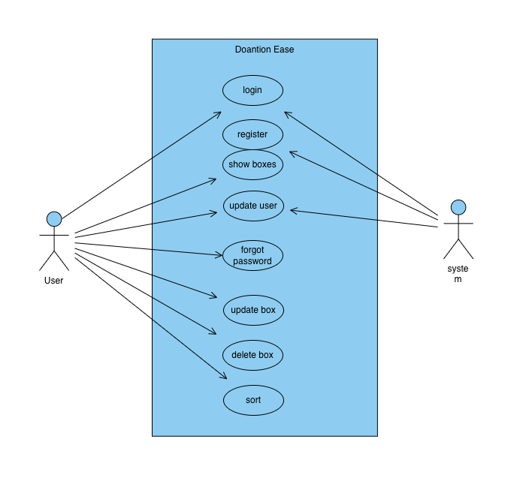

and their retu